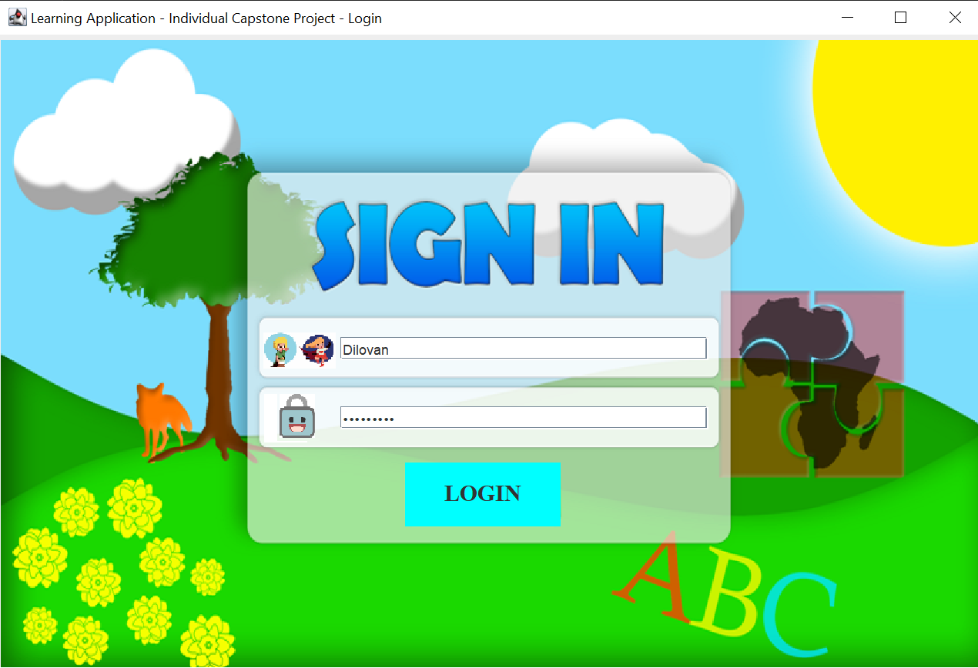

Educational Game for Children

Individual capstone

Dilovan Panawandi | dp1906435 | Dr. Bourazeri, Katerina | Dr. Barakat, Lina | Undergraduate

**Acknowledgements**

My project wouldn’t be as it is if not thanks to my supervisor Dr. Bourazeri, Katerina who helped me all the way by giving me advice on changes and/or additional ideas that could be added to the project, my fellow computer science friend Samatar Jamal Jama and Hassan Ahmed who helped me by encouraging me, giving advice on what tools I could be using or coding advice and especially my cousin Brusk, who is now writing his bachelor in 3D Graphics. Even though he’s busy, he’s been taking time on the side to design my project.

**Sources**

Including the book “Java for Programmers” by Douglas A. Lyon that I’ve been borrowing since the beginning of my final year from the University of Essex library. Content of chapters the book has is about 44 Chapters. It goes through all from the basics in Java to even Java Beans, EJB Security, RMI etc.. but the relevant chapters for my project where: Chapter 18, Introduction to Swing, Chapter 19, Introducing Events, Chapter 22, Using the Keyboard, Chapter 26, Introduction to Drawing Shapes and Chapter 28, JDBC.

**Abstract**

My project focuses on helping children to further develop their knowledge and skills on specific topics and subjects. To achieve this, I developed an application written in Java, which includes three different mini-games: a language/alphabet game, general-knowledge(animals and/or insects) and an interactive world map game.

The application has a login page where every child will have an unique ID and password for their account. Depending on the children’s age, the level difficulty will increase, e.g., first graders at primary school will work with (by choice) cities, counties or a combination of both in the UK, whereas second graders will have other options (i.e., countries or flags) in Europe or a combination of both and so on.

The easiest level of the language/alphabet game is about learning letters in both uppercase and lowercase. In this game, children will see an image of a letter and have to type the correct letter in the input bar. This game also has a combination choice of uppercase and lowercase letters.

The first level of the animal game is about learning and knowing what different animals look like. It’s a different variation to other minigames as it includes images of animals. As the level increases, the game becomes more complicated. Insects, bugs, and animals are combined and the number of questions is increased.

Motivation...................................................................................................................................

**Inspiration**...........................................................................................................................

87

88

86

78

75

17

Organising...................................................................................................................................

98

91

83

81

8

Games..........................................................................................................................................

4

Home page...................................................................................................................................

4

Login............................................................................................................................................

4

**Main text**...................................................................................................................................

Table of Contents

5-8

9

**Project planning**.................................................................................................................

9-10

Where to begin............................................................................................................................

Solving problems........................................................................................................................

10-13

How to begin...............................................................................................................................

14-16

**Non-technical struggles**....................................................................................................

16

16-17

**Conclusion**............................................................................................................................

17

Difficulties..................................................................................................................................

17

Execution....................................................................................................................................

17-18

**Educational Game for Children**

**Inspiration**

**Motivation**

I have been playing video games most of my life, I have fond memories of fun times when I was younger. Figuring out the mechanics of the game, the maps as well as how to use tools. My experiences have made me realise there are many things to be learned from video games. English is not my native language, I learned lots of vocabulary, grammar and mathematical skills largely through video games, I also learned problem solving skills, time management and how to think strategically to break down problems. I believe these are valuable skills to learn at a young age and they can be taught exceptionally well through the gaming experience. I wanted to create something that allows children to learn but to also have fun at the same time.

This project has allowed me to create something which not only makes use of my programming skills but at the same time I am able to turn my hobby into a product that can educate children. This has luckily made it easy for me to stay engaged and motivated throughout the project. I realised that I can use my gaming experience to guide my programming.

I also wanted from the beginning to create a project that was relevant, something that people could interact with and make use of. I did not want my project to be theoretical or too technical because I believe that takes away from user experience.

Another inspiration for choosing this project was based on my career. I want to apply for application programming roles in the near future, Knowing that I will be able to use this project as evidence of my capabilities and skills convinced this project was worth it.

**Technical document**

**Login**

My login page was designed by my cousin Brusk where I asked him to make the design relevant to my project where there’s a fox, letters and Africa in the background. For the project I decided to use MySQL as my database since MySQL is what I learned from my first year of Computer Science because I want to use everything I’ve learned if possible, in this project.

Login page has two text fields for Username and Password and also one login button as shown in the image below. If Username or Password is incorrect a small label with the message “Username and/or password incorrect” will be displayed in between the password text field and the login button.

The applications background music is added from my Soundmanager class that has all my sound effects and background music stored. Images below are code for login page.

Connecting our database to the login form. In the image above I’ve given our “Login” button action listener/action event to take action if it meets conditions. The button is connecting to our database. Which in this case we have two strings that are initialised after our JTextField and our JPasswordField. Like in the image below.



We did that to receive user text specifically in those two fields. And the formula to return correct usernames and password is in line 99.



And in the if loop I have two coniditions, one which if found true open our home page and dispose the current one (login page) else if found false then set our label text visible saying “Incorrect username/password!” and close connection with database at the end.

**MySQL Workbench**

I decided to use MySQL workbench since it’s the tool that I’m the most comfortable and confident with. Unfortunately MySQL is not sufficient enough to provide proper security for database encryption but it provides robust data security(Wi-Fi protected access) protecting secure connections, data encryption, authentic services and data etc..

The image above shows how I add new values to the database. First we insert into our scheme ‘login’ and our table ‘username’ with the elements id, username, password and level and values 5, Bourazeri, Katerina, 3.

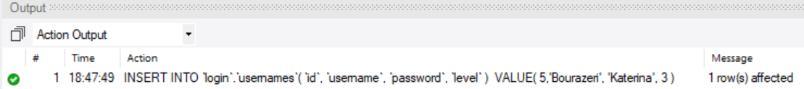

Output results after executing script. Green check mark means successful and it tells you how many rows have been affected by this. But if I want to update or apply some values I use this formula:

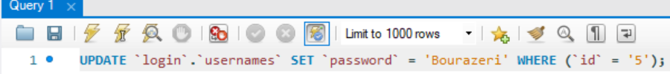

On execution of script we change id 5’s password to “Bourazeri” and this is the output. We also changed id 5’s username to Katerina.



**Home Page**

The home page was inspired by an image I found at google. Each minigame is visible and available at anytime and have relevant image to showcase which minigame each are. The applications home page gives the user the following functionalities: To be able to pick minigame of interest, turning off or on the background music and to also quit the application.

Background is meant to be childish in a positive way where it’s colourful and makes you fell like you’ll remember and like it. Each game will give user the option to go back to the home page after playing each minigame.

Most of the code is similar, therefor I will show that I think is important.

If Map button is pressed then open world map game and dispose current frame (home page).

This is the code to turn of the background music. I had to create the Boolean doStop and initialize it as true. 

What the if loop does is: if button is pressed which is true and the background music is playing then stop the music and print it out to the system “Music off”. Else continue the background music when pressed again.

**Games**

**Alphabet**

The application has a ranking or level system from one up to three where depending on your age or skills will give you tougher challenges and every level of each minigame are programmed to be different so the user experience won’t always be the same. As for the first level of the Alphabet or rather language game the minigame has one image of (depending on users choice of playing with only uppercase, lowercase or both) a letter that needs to be typed in the text field input and if correct letter is typed then user will move to the next question however if the user types the incorrect letter the question will not change and user will not be able to go forward. Examples of the game shown in images below.

The image above is to show what the users will see when they get to pick specifically what they want to play with and there will always be a back button in case they change their minds or for any other reason.

We have two labels, one for the images and the other for the questions. We use the same labels for each question but for every if condition that is being met as true the labels change question number and image.

If statements for each question, if first one is answered then move to next current until the end.

After the last question is answered the following image below will be shown.

The next button is set as enabled(false) so it won’t do anything and the home button will only appear after the last question is answered.

Image above is the code for the previous image. Home button will send user back home. Home button is already added to the frame but it’s set as visible(false) until this if loop condition is met.

Second level of the minigame will be like multiple choice questions. Users will work with really simple words and learn simple grammar. One example could be how to use grammar for the word apple, A apple, An apple, The apple. Results will be given at the end of the minigame for level two and three.

For the third level of the language game we can now expect that the children have already learned the alphabet and are now advancing to learn how to write sentences. So the plan for level three is to give users a short sentence where one or maybe two words are missing. Therefor the challenge will be for users to attempt in finishing the sentences and also needing to type the words correctly. This minigames functions will be slightly different than the first and second level. They will have to type in the sentences itself but users will potentially be given help by having a voice message reading the correct words to complete sentences.

**Animal**

First level of animal game is multiple choice questions with images of animals for every question and results will be given after the attempt. When building this application I tried to remember and think of what I would enjoy as a child playing an educational game. So I thought that with a lot of variation comes a lot of enjoyment. And as a child I found animals to be very interesting that’s why I decided to add this type of minigame to the project. The minigame is straightforward and fun because you will potentially see animals you’ve never seen or heard of and the multiple choices could be tricky. Example shown in image below.

To get the radio buttons I had to implement them as shown in image below.

But I also need to make sure that only one button can be pressed/clicked at a time therefor I decided to use the Buttongroup component which manages selected and unselected states for a set of buttons. It guarantees that only one button can be selected at a time because all buttons managed by Buttongroup instance are unselected.

We use a for loop to loop through our buttons and adding it to the frame with a panel so then the Buttongroup adds it.

Image below is my code that will set results button visible when the application has gone through all the questions, return results with correct amount of answers and return us back to home page.

This is how we set up every question with optional answers. radioButton[4] creates four radio buttons, from then we can change or set the radio buttons text to anything. The labels are structured like the alphabet game, they change for every question.

And this Boolean checks for us if correct answer has been selected and which number of question. The method is being used in a for loop that you can find on the images above.

For the second level of the minigame I decided to add some insects to expand the pool of creativity that I can add to the application. In other words, the minigame will have many more options than just having animals. It could be a quiz about only specific bugs, insects in general or Arachnida/Arachnids which is a class of it’s own and in the class are the following: spiders, scorpions etc.

Third level of the animal minigames would be a mixture of all kinds of animals and insects combined or picking specifically classes like mammals. This minigame is all about variation and simplicity.

**Geographic**

Regardless of anyone’s age personally I believe that map games are fun and easily repeatable. I enjoyed map games as a child and even to this day I find it very fun because it’s challenging and simple. The game is beneficial as it helps with you getting a “better memory”. First level of the game will teach children about cities and counties in the UK where users will have the option of choosing only cities, counties or both.

Second level of the game will be different as you will learn about flags around the world and each countries capital city. All the level difficulties of this minigame will have the same “game” mode compared to the other minigames where for example in the first level of the alphabet game will be different to the second level.

And in the third level of this minigame it will be a typical world map game with more than 10 questions and around 15+ seconds timer for each question. Minigame does also have a reset button with sound effects for clicking on correct country and the incorrect ones. Game also have a home button, when pressed you will be sent back to the home page. Example shown in image below.

Mouse events are need for this minigame, on the image below we use mouse event for when the mouse is clicked. If game is not over we have set if conditions: If correct country is clicked then set text as “Correct” with green letters, add points + one point to the score, reset counter time to zero and play a positive sound effect else set the text as “Wrong” with red letters, play a less positive sound effect reset counter and add no points to score.

Ten seconds timer. If questions are less than ten then add +1 question so it will keep track on which question you’re on and load a new question with timer starting again on zero. Else if questions are ten or more then give us an “alert” message saying how much your score is, end the game and timer.

Sets the countries as white and the outer lines as red.

We use a txt file for our contries and here’s the code to read it in Java.

Loading the questions at random.

**Solving Problems**

Problems I had during the making of my game kept increasing. Any kind of problems from something simple and small to somewhat a big problem kept occurring. It kept delaying the progress of the project so sometimes I had to neglect the little things like background music or sound effects and focus solely on the minigames. My passion for this project was “impeccable”, whenever I hit a brick-wall and felt like my progress completely halted my burning passion and motivation kept me going.

I had issues connecting my database to my application very early on but it didn’t take too long before I solved the problem. My solutions tend to be that I take a small break from the current problem and make progress elsewhere to boost my motivation and confidence so I could re-attempt solving the problem later on. On the other hand whenever I had a problem with coding my motivation was drained heavily. I had to think of many different methods that could potentially solve my problem whilst coding and executing the first method that came to mind.

So at times I had to do some research and look at example that are similar to my problem and imitate the solutions but adding my own twist to it since the examples could never directly solve my problems.

**Project Planning**

**Where to begin**

Knowing where to start was tough but before planning everything for the project I started with my Home Page and thought of what is needed for the project afterwards. Think of it as if my Home Page is the center of a bubble map or thinking map.

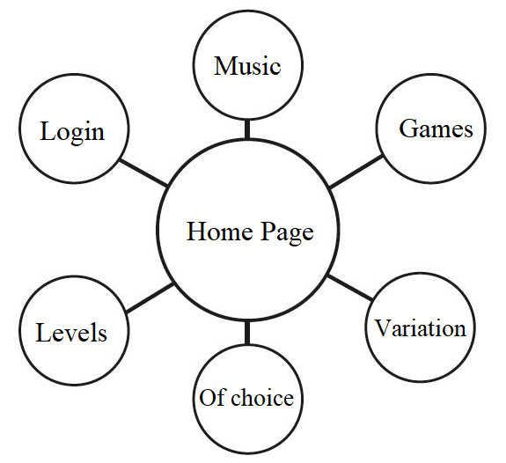

The image above explains what I meant by a thinking map/bubble map. After creating my Home Page is when I got most of my ideas but then it also became a challenge not knowing what to begin with. The plan was to setup everything like packages and having essential classes for each package, design of the project, my database and also adding comments to important classes writing what work is needed to do.

Comments I made in my Main Java class to explain or make my writing more clear.

**How to begin**

After planning on where to begin with my project all I had to do was run my application in Java, look at what I have, think of all the ideas I’ve gathered and work on what I felt like was needed for the application in the moment. Which was adding buttons to my home page with functionalities like disposing current frame and opening a new one and adding mouse events so whenever mouse is entered or hovered above button, button changes colour as in the example below.

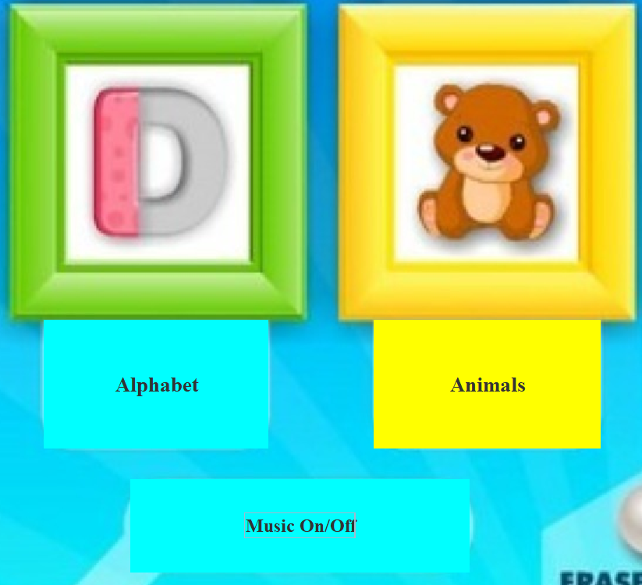

And the code below:

At this juncture working on the project was not a problem. I ended up with adding my Login Page, database and music.

The image above shows my table with the elements.

What the database currently looks like.

SoundManager class handling music.

**

When I wanted to work with a specific class, I ran the class in the Main class and also added comments (image I used earlier) that are essential for the project as a whole(Design, database, levels etc..). Also having a test class that was used whenever I felt like a class needed some more work or almost couldn’t have anything extra added to it doing some “experiment” on it without me “wrecking” the class.

How I split my classes into packages, files for music and images and also having my database connector there (image above).

**Non-technical struggles**

Outside the programming, the biggest struggle was time management. I had many other deadlines around the same time as this capstone, which meant I had to figure out how to prioritise. I did not accomplish as many tasks as I wanted to early in the year which meant I had a lot of pressure on me right before the deadline. The lack of good time management meant I could not focus on each individual task for as long I wanted to and which had a snowball effect on my productively. It also meant I had to abandon a lot of great ideas that I came up with later on.

Another struggle I faced was working during Ramadan. I am a Muslim so during the month of April I was fasting every day, this meant no water or food until sunset. This really effected my productively during the day. I was fatigued and could not focus for more than short periods of time. During the night I would be eating and praying as well, this of course took a lot of time.

I was at home in Norway for a significant period of time dealing with family matters, during those months I was anxious and because of that I did not get to work on my capstone as much as I was hoping for.

**Conclusion**

**Difficulties**

Coding the alphabet and the world map minigame was an arduous journey. After finishing the animal game, I hoped that the alphabet game would be as undemanding as the animal game but that was not the case. In the alphabet game everything seemed to be fine but sometimes when getting past question three or four, the input would be changed and by that I mean if you saw an image of the letter “D” and typed the letter “E” the game would jump to the letter “F”.

On the other hand the world map game was difficult because it was quite demanding. I had a good start on the minigame but also hit a brick-wall quite early. It got to me and I started feeling pressured so what I had to do was leave it until I finished the other minigames and then get back to it as quickly as possible with a clear mind and a fresh start.

Other difficulties with the project was to connect the whole project. From the login page to the home page, from the home page to the desired minigame and then from the minigames going back to the home page without any errors/bugs. Outside the programming, the biggest struggle was time management. I had many other deadlines around the same time as this capstone, which meant I had to figure out how to prioritise.

Problems I had during the making of my game kept increasing. Any kind of problems from something simple and small to somewhat a big problem kept occurring. It kept delaying the progress of the project so sometimes I had to neglect the little things like background music or sound effects and focus solely on the minigames.

I also have some issues or ideas that I could not fix and/or add to the project. For example in the world map game, I have an issue with the sound effects where when I get correct answer a sound effect do play but it will only play once and the same goes for incorrect answers. Having three minigames is good but I did wish I could add one fourth minigame which would be Maths. I do believe it would be a fun minigame as it would be the most challenging game. But overall I am very happy with my project and proud of it.

I’ve never written more than approximately six hundred lines of code but with this project I’ve overcome those numbers. Just my World map minigame has about five hundred + lines of code. So all in all the project as a whole is probably close to one thousand five hundred or even two thousand lines of code.

**Execution**

From the beginning I wanted to create a project that was relevant, something that people could interact with and make use of. After creating my Home Page is when I everything started going smother, slowly but surely. After I setup everything like packages, classes for each package, design of the project(images), my database, sound effects and background music the project came together as a proper application. The applications home page gives the user the following functionalities: To be able to pick minigame of interest, turning off or on the background music and to also quit the application.

The application has a ranking or level system from one up to three where depending on your age or skills will give you tougher challenges and every level of each minigame are programmed to be different so the user experience won’t always be the same. As for the first level of the Alphabet or rather language game the minigame has one image of (depending on users choice of playing with only uppercase, lowercase or both) a letter that needs to be typed in the text field input and if correct letter is typed then user will move to the next question however if the user types the incorrect letter the question will not change and user will not be able to go forward.

First level of animal game is multiple choice questions with images of animals for every question and results will be given after the attempt. The third level of this minigame is a typical world map game with more than 10 questions and around 15+ seconds timer for each question. Minigame does also have a reset button with sound effects for clicking on correct country and the incorrect ones. Game also have a home button, when pressed you will be sent back to the home page.